|  |
| --- |
| V-Trans: A Vison Based Integrated Intelligent Transportation System |

**Project Name**- V-Trans: A Vison Based Integrated Intelligent Transportation System

**Project Area**- Smart cities, metropolitan areas etc.

## Background and brief introduction- Now-a-days the number of vehicles are increasing tremendously. Therefore, the traffic congestion, road accidents are also taking place at a huge number. In our project we have tried to completely eliminate traffic accidents those are taking place in cities and metropolitan areas using ITS technology that virtually connects vehicles with other vehicles, pedestrians, and the road, we are working to build a safer mobile society. Also we have tried to reduce the traffic congestion problem in those respective areas in a smarter way.

## Innovation-

## A smart IT system must have a smarter and efficient way to communicate with roads, other vehicles and people. We have described our ITS systems as follows.

## Automated license checking and vehicle number plate detection at city entrances or toll gates by image processing approach.

## Vehicle number plate detection by fast image processing approach.

## Alerting the car that runs at a high speed in the city by vehicle to road communication systems.

## Avoiding sudden accidents with vehicle and pedestrians by vehicle to vehicle and pedestrian communication systems

## Benchmarking –

|  |  |  |
| --- | --- | --- |
| **Features** | **Toyota ITS** | **Our ITS innovation** |
| **Pedestrian warning** | Android using pedestrians only | All Pedestrians |
| **Vehicle to Road communications** | Limited Range | Range up to 500 meters |
| **Vehicle to Vehicle communications** | Using RF modules | Using digital image processing and xbees |
| **Vehicle number plate detection** | No | Yes |
| **Automated license Checking** | No | Yes |
| **Vehicle information** | No | Yes |
| **Cost** | High | Low Cost Up to 20000 Per one unit |

## Further details of Toyota ITS innovations visit: - http://www.toyota-global.com/innovation/smart_mobility_society/intelligent_transport_systems/

**Technical description-**

* **Automated license checking and vehicle number plate detection-**

At the Toll gate, we often face traffic congestion due to presence of vehicles making a large queue. As the license checking are done manually by a checker the checking process gets delayed and a huge traffic congestion occurs. In our project we have made an automated license card checking machine on which the driver has to place their license card and the machine will automatically detect the license card number. In any case if the driver fails to give the license he/she will be taken to another lane where they have to consult to the officials. This system will automatically save the driver license details, vehicle details and also will reduce the time delay which occurs in manual checking and also the traffic congestion will reduce. At the entrance separate high definition cameras will be used for vehicle number plate detection.

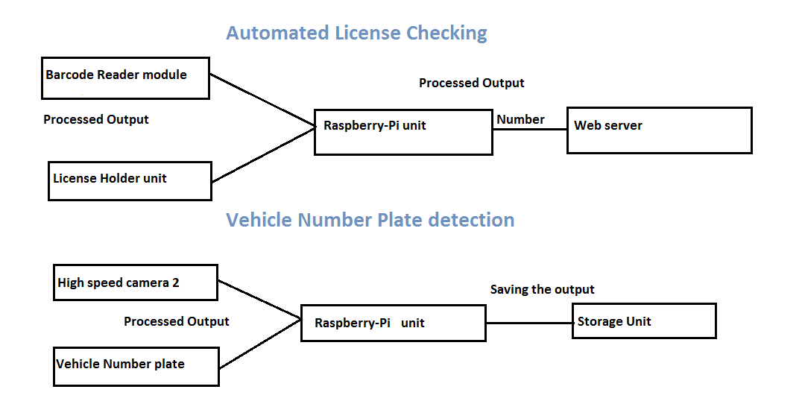

* **Vehicle to road communication system-**

As per the rules of govt. of India the vehicle speed in towns and cities must be in between 45-60 kmph. But often this rules are being violated by some irresponsible drivers who don’t know what are the problems might occur due to high speed driving. Therefore, we have designed an automated driver alert system. In this system the driver gets a warning if there will be any junction/traffic system present on the way of the vehicle. It works before 500 metre away from the traffic signals. When the traffic signal is red it will transmit a signal over 500 metre range and the vehicles which will be running above the speed limit they will be warned. This system will not only alert the drivers to limit their speeds but also prevent accidents in crowded areas as a large crowd occurs at the junctions/traffic signals.



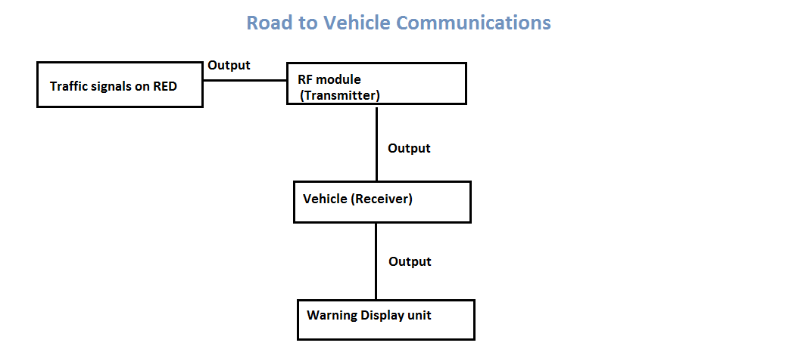

* **Vehicle to vehicle and people communication systems-**

Sometimes accidents occurs due to ignorance of road details to the driver. It can be avoided by the application of vehicle to vehicle and people communication systems in which the vehicles are internally connected to roads, traffics and if any problem with the road occurs then then it will circulate among the vehicles and everyone will get the message. This system will help the drivers to navigate in a correct way and also reduce vehicle collisions. In this communication system we are going to use image processing which will work at small junctions. For example, we can take two cars which are passing simultaneously, one is in the main road and another in the link road which further links the main road. So we can find any type of collision between the two cars. But in our approach we have used cameras to detect any type of object moving on the road. If there will be two cars, then the car which is moving on the link road will be warned to stop his/her car. And if there will be any human then the car will be warned to slow his/her vehicle speed.



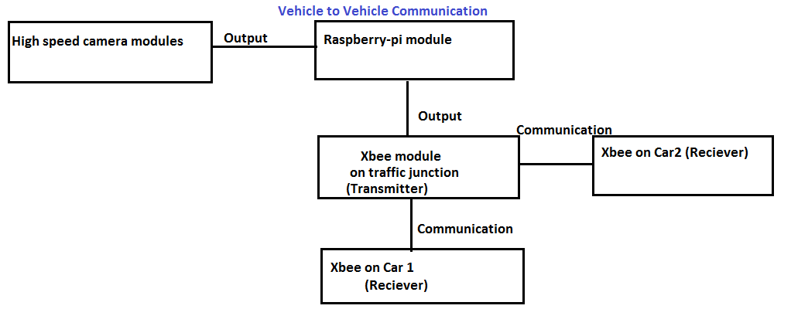

Your text here

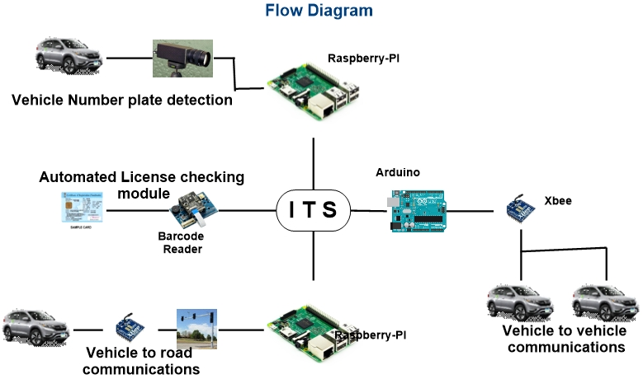

**CONCLUSION:**

In this century, we all are growing with advance of technology whose speed is much higher than the speed of our aging. Similarly, we have seen the competition of technology in the field of transportation and developing the vehicle. We have seen the fastest car in the road which is increasing day by day and also seen the cheapest car. Every time there is a change which caught our eyes wide open and minds to wander the innovation. And we face the world today as more challenging than the world we have seen the day before, every time we face new challenge to develop the technology and again challenge the world opposite to us. Sometimes, this advance of technology may cause problem to some other people. The increasing speed of vehicle leads to increasing the reckless driving on the road and increases the accident on the road and risking a lots of lives of the people. Here comes a way to improve the safety of the vehicle, trespasser and others. Now we need to pressure on minds and choke out a new solution or new way to have a safer travel than the shorter travel. As it’s first important to reach at the destination then losing own or other lives before the destination in order to reach sooner.

In our project, we have focused more on the safer travel the than faster or cheaper travel. We also focused on the unnecessary time spent or delay at the toll gate and check post. Through this project we made an approach to improve road to road communication and a new way to avoid the delay occur at Toll gate in most part of the country. We made a red light alert or zebra-crossing alert to driver to slow down their cars at a particular place. We tried to introduce a new method to avoid the serious and major growing accident which occur due to the vehicle at the turning or at the junction of the road by alerting the driver about the object at the other side of the junction. We have brought a new solution to avoid the accident that occur due to sudden appearance of an object (person or vehicle) on our way during our journey. This can save lives of lots of people and led an accident free travel which is our key motive under this project.

We feel happy and grateful to contribute some idea and effort to your competition. We are grateful to you for organizing such a competition or providing such a platform to entertain the young minds and to present their innovation.